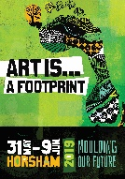
TAKE A WALK AND DISCOVER HORSHAM’S PUBLIC ART
Walk, admire and see if you can answer these questions on Horsham’s art and cultural heritage trail:
Start and end your walk in Wilson Street at the Horsham Town Hall:
- A tapestry hung in the Wilson Street foyer of the Horsham Town Hall in 2018 was created for Horsham’s Bicentennial in 1988 by at least 20 local weavers. The scene in the tapestry depicts Horsham in what year?
1900 1890 1898 1888

- Gallery Alley and Ward Street show art in what format?
Sculpture Light box images Mural of birds Woven art

- Name the winner of the Art Is…“Artists on the Side” competition. (Hint: You will see the various works of art in shop fronts as you walk through Horsham’s CBD.)
Your answer is: ……………………………………………………………..…..

- During a previous year’s Art Is…, a large mural was painted on a supermarket wall. What does this mural say?
“Shop here!” “Welcome to Horsham, Victoria” “Best in the Wimmera”

- During the Art Is… Festival in year 2000, a colourful artwork was noisily created in Roberts Avenue. Can you pick which one it was?:
Pavement art Metallic sculpture Wooden Totem Pole
- The community piano is where?
Darlot Street Urquhart Street
O’Callaghan’s Parade Roberts Avenue
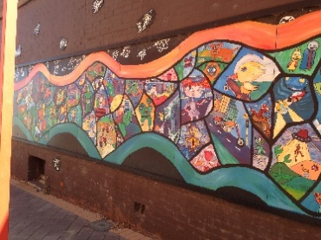
- In which Horsham laneway is this mural?
Market Lane Bradbury Lane Jos Lane

- “Aerial” depicts what type of bird in Jos Lane?
Plover Pelican Eagle Raven

- “Writing on the wall” engaged children between 10 and 18 years from culturally diverse backgrounds in 2013. Apart from finding these writings on seats along Firebrace Street, where else will you find them in Horsham? (example )
Library Plaza Theatre Aquatic Centre
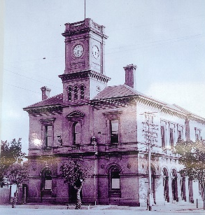
- What was this former building’s purpose in Horsham?
Bank Gallery Post Office Fire Station
- Dr. Anton Hassell created a sculpture on the corner of Firebrace Street and McLachlan Street? What is it?
Fountain Flag Bell Tower Bike

What bird sits at the top of it?
Corella Galah Seagull Pidgeon

- Which building in Urquhart Street has a glistening mosaic of Taylors Lake on its front wall?
Uniting Church Centre for Participation Wesley Performing Arts

- How many of the 11 mosaics at the Goolum Goolum Aboriginal Cooperative in Urquhart Street, depict birds? 1 4 7 10

- The Horsham Botanical Gardens was originally designed by William Guilfoyle who was also the curator of which famous gardens in Melbourne?
Flagstaff Gardens Royal Botanic Gardens Treasury Gardens

- On the bend of Eastgate Drive into Barnes Boulevard, a sculpture by Dónal Molloy-Drum is in memory of which major event in Horsham?
Fire Flood Drought Harvest

- The artwork “Wimmera – Woven Vessels” can be found suspended where in Horsham?
Exchange Hotel Catholic Church On the Wimmera River banks

- Name the artwork you like the most in the Horsham Regional Art Gallery in Wilson Street.

Your answer is: ………………………………………………………………..

WE HOPE YOU ENJOYED EXPLORING HORSHAM’S PUBLIC ART

If you return your clip pad to the Horsham Regional Art Gallery reception (Wilson Street), you are welcome to pick up a showbag containing regional art and culture guides, plus a coffee voucher for the Exchange Hotel.
SEE HORSHAM’S PRIVATE, ACCESSIBLE ART (just outside the CBD)
Drive to admire and see if you can answer these questions on Horsham’s art and cultural heritage trail:
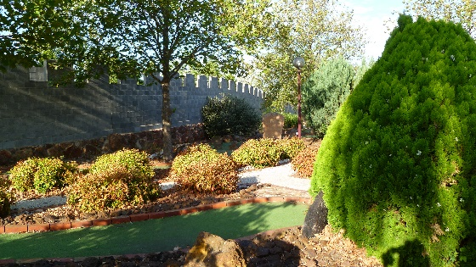
1. Which restaurant features these structures?
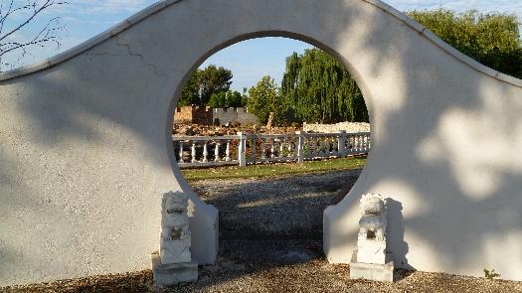

Chick Pea Fig Tree Cafe Capital Bistro Toys Restaurant

- Which restaurant features fine art, sculptures and wildlife?
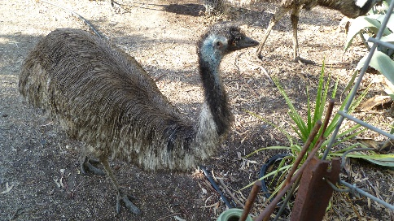
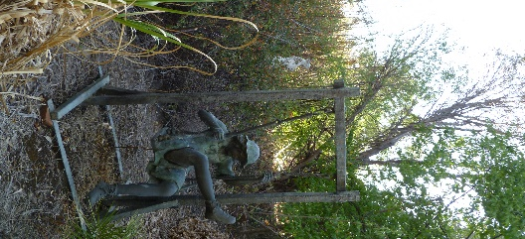

Olde Horsham Café Jazz Bar 3400 Horsham Palace

- Horsham College has a wall sculpture in Baillie Street depicting 5 Wimmera indigenous groups? Interestingly, all their names start with one of only two letters of the alphabet. What are they?
A & B Y & M S & P W & J
- The sculpture by Dónal Molloy-Drum at the front door of Horsham Grains Innovation Park features three forms of plant life – what are they?

Wheat, lentils and plant roots Oats, wheat, barley

Nettles, roses and daisies Thistles, Buffalo Grass and Kangaroo Paw

WE HOPE YOU ENJOYED EXPLORING HORSHAM’S PRIVATE ART

If you return your clip pad to the Horsham Regional Art Gallery reception (Wilson Street), you are welcome to pick up a showbag containing regional art and culture guides, plus a coffee shop voucher for the Exchange Hotel.

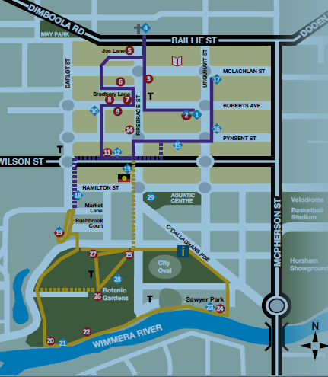
HORSHAM CENTRAL BUSINESS DISTRICT
To Horsham College
To Grains Innovation Park
To Toys Chinese Garden Restaurant and to Olde Horsham Restaurant

